**SKIMMING**

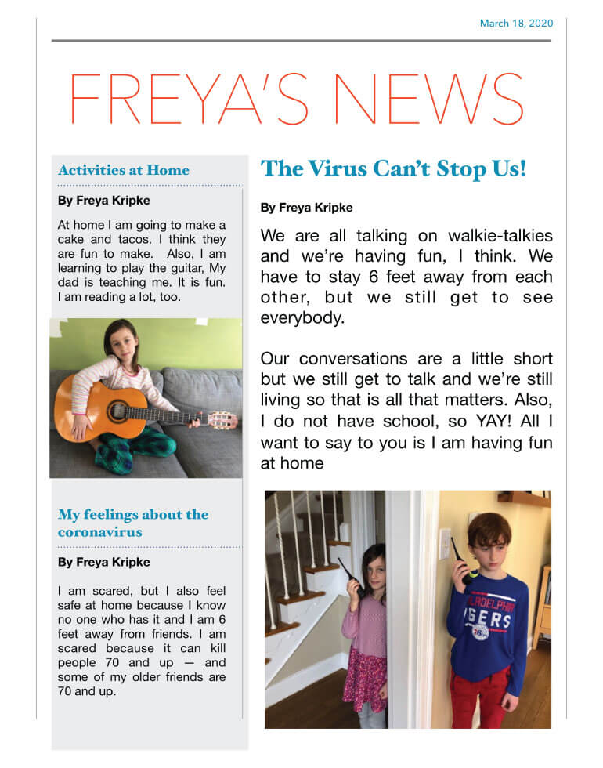**Highlight the article as our example in the class, using this technique**

**Note: remember is just to have an idea…not all the article.**